Behind Enemy Lines: Investigating Crozier’s Paradox and Recognition of Nestmates through an Individual-Based Model

Credentials

# Abstract

# Introduction

* Chemical cue recognition
* Crozier’s paradox
* Previous attempts at resolving the paradox
* Recognition models decoupling and explanation
* Our model and intraspecific parasitism
* Brief conclusion

# Materials and Methods

## The Model

The purpose of the model is to study how cue diversity and abundance may evolve in context of Crozier's paradox focusing on ant colonies that can forage or steal resources from another colony. The simulated population comprises of $N_{colonies}$ colonies containing $N_{workers}$ workers each. Each worker ant can choose between foraging from a global resource pool or stealing from another colony based on the relative availability of food in the environment and the number of available colonies available for exploitation. Workers undergo a recognition process whenever they try to enter a colony and entry is permitted if it is recognized as a nestmate. Gillespie algorithm was utilized to schedule foraging and stealing in the model dynamically. Once an action of foraging, stealing, or returning to one’s colony is completed, the period before the next action is sampled from an exponential distribution with a rate parameter 1.

## Recognition Cues

Each colony has a unique chemical profile that serves as the recognition signal against which an intruder is compared and consists of $N_{cues}$ homologous groups. Said compound groups can also be seen as the principal component along which sets of hydrocarbons vary and are independent of each other by definition.

For a colony $r$, the abundance of the $i^{th}$ compound groups are denoted as $c_{r,i}$, and the total cue abundance for a colony denoted by $C_{r}$ is the sum of its compound groups’ abundances. Each time a colony $r$ reproduces a daughter colony $d$, the $i^{th}$ compound group abundance $c_{d,i}$ is chosen from a normal distribution with mean $c_{r,i}$ and standard deviation $μ_{cues}$. Here, $μ_{cues}$ represent the strength of mutation for the chemical cues. Chemical abundance values $c_{r,i}$ have no upper limit but are lower bound at 0. If the simulated population evolves a chemical profile where all cues have a value of 0, we have essentially lost the cue recognition system, and the simulation is terminated.

Workers have a profile that varies around the parent colony profile. The $i^{th}$ chemical group abundances for a worker $w$ from a parent colony $r$ is sampled from a normal distribution with mean $c_{r,i}$ and standard deviation $μ_{cues}/10$. The smaller spread of the sampling curve ensures that workers in a colony have sufficiently similar profiles and provides a high relatedness within a colony to the model.

## Foraging, stealing, and resource consumption

All workers have access to a global pool of resources. When a worker leaves the colony, it probabilistically decides to forage or steal food from another colony. This decision is dependent on the amount of food available in the global pool $(F)$ and the number of colonies alive $N_{alive}$. The probability of foraging is then defined as:

$$P\left(foraging\right)=bernoulli\left(\frac{F}{F+N_{alive}-1}\right)$$

If the worker forages, then one unit of food is acquired from the population food source by the individual. If the worker is stealing resources from another colony, a colony is chosen at random for the worker to invade. The intruder undergoes a recognition process in which a worker ant in the target colony determines whether the intruder is a nestmate or a competitor (see section below). If accepted as a nestmate, the intruder raids one unit of food from the target colony. Since we use the Gillespie algorithm for continuous-time simulation, actions are performed in a random order, and all colonies forage and invade simultaneously. Workers which have successfully acquired food and are returning to their colonies face another recognition process from a nestmate worker. If accepted as a nestmate, a unit of food resource is added to the colony stock. In cases where recognition fails and the worker is misidentified as an invader, the resource is discarded, and the worker is rescheduled for the next task.

Our model also accounts for the metabolic costs needed to produce CHCs. Whenever an individual from the colony $r$ acts, there is a decrease in the colony's food stock $F_{r}$ given by

$ΔF_{r}= \frac{m*C_{r}}{2000*N_{workers}}$

Where $m$ is the cost of CHC biosynthesis per unit of CHC. This models a biological scenario where CHCs are lost outside the colony, hence average individual CHC production costs are subtracted at action points. This formula was chosen such that costs increase as the total cue abundance in a colony increases. The division by 2 and $N_{workers}$ in the denominator is to normalize across two actions needed for gaining one food source and to normalize the total number of workers, respectively. If a colony exhausts its food stock, it dies.

Our model allows for discrete regeneration of the global pool of resources. 300 units of food are provided periodically as the global pool to the population after a constant time interval $t_{gen}$. Workers can then forage from this global pool but must rely on stealing from other colonies once the pool is exhausted before the regeneration point is reached. If there are any food resource remnants in the global pool right before the regeneration point, they are discarded.

At the start of the simulation, each colony is initialized with 25 units of resources in their stock, and the global pool is initialized with 300 units of food.

## Recognition Process

Every time an individual attempts to enter a colony, a recognition procedure takes place to determine if the individual is a nestmate or intruder. A worker from the resident colony intercepts the intruder and calculates the chemical distance between the intruder’s chemical profile and the resident colony's chemical profile. This chemical distance can be calculated in three ways deriving from the Bray-Curtis distance in our model:

Overall similarity (Gestalt): The chemical distance is calculated as the Bray-Curtis distance between the profile of the intruder $i$ and resident colony $r$, given by $$BC_{r,i}^{G}=1-\frac{2\sum_{k=1}^{N_{cues}}{}\left(c_{k,r},c_{k,i}\right) }{\sum_{k=1}^{N_{cues}}{}{(c}_{k,r}+c_{k,i})}$$

* This is quite similar to the conjectured recognition in the Gestalt model (insert citation). Here, both individuals would either reject each other or accept each other due to the symmetric nature of the formula.

Undesirable-absent (U-absent): This recognition model focuses on ‘unknown’ compounds that are not present or less abundant in the resident colony profile compared to the intruder profile. The chemical distance between the profile of the intruder $i$ and resident colony $r$ under this model is given by a modified Bray-Curtis distance as $$BC_{r,i}^{UA}=1-\frac{2\sum_{k=1}^{N_{cues}}{}\left(c_{k,r},c_{k,i}\right) }{\sum_{k=1}^{N_{cues}}{}\{2c_{k,i} if c_{k,i}<c_{k,r} {(c}_{k,r}+c_{k,i}) otherwise }$$

* Here, the compound groups that are present in the resident but absent or less abundant in the intruder ${(c}_{k,i}<c_{k,r})$ are ignored, and both the values are set to $c_{k,i}$ before calculating the distance. Thus, the compounds less abundant in the intruder lower the chemical distance.

Desirable-present (D-present): In this recognition system, emphasis is placed on whether the intruder has all the compounds that are present in the resident colony. Thus, while calculating distance, if compound groups in the intruder that have a higher abundance than residents are ignored, we arrive at the formula: $$BC_{r,i}^{DP}=1-\frac{2\sum_{k=1}^{N_{cues}}{}\left(c_{k,r},c_{k,i}\right) }{\sum_{k=1}^{N_{cues}}{}\{2c_{k,r} if c_{k,r}<c_{k,i} {(c}_{k,r}+c_{k,i}) otherwise }$$

* Here cues that are higher in abundance for the intruder help lower the perceived chemical distance.

Our model separates cue expression from cue perception. Each colony has a tolerance curve, which gives the rejection probability for a specific value of chemical distance. The rejection probability is the binomial probability with which the intruder or worker is rejected entry into the colony. Each colony $r$ genetically encodes two variables $T_{int,r}$ and $T_{slope,r}$, which provides for a linear tolerance curve. The rejection probability for a given chemical distance $d$ is given by:

$$P\left(rejection\right)= T_{slope,r}*d+T_{int,r}$$

Once the rejection probability is obtained from the chemical distance and tolerance curve of the target colony, a Bernoulli sampling is performed. This recognition process occurs every time an individual attempts to steal food from another colony, or when individuals with food return to their colony.

The tolerance curve itself can either be a fixed property of the model (default) or co-evolve along with recognition cues with mutation strength $μ_{tolerance}$. In the default scenario where tolerance curves are non-evolving, variables $T_{int,r}$ and $T_{slope,r}$ are not inherited but are sampled from normal distributions with mean 0 and 1 respectively, with standard deviation $μ_{tolerance}$. This sampling imparts demographic heterogeneity to our model such that the rejection probability has the same value as the chemical distance between the profiles on average at the population scale.

In the scenario where tolerance co-evolves with recognition cues, the colonies start with a flat tolerance curve such that all entry attempts by workers have an approximately 50% chance of acceptance. The recognition system can evolve adaptively, with the inherited tolerance variables for a daughter colony $d$ from parent colony $r$ are given by:

$$T_{int, d}=Normal\left(T_{int, r} , { μ}_{tolerance}\right)T_{slope, d}=Normal (T_{slope, r} , { μ}_{tolerance})$$

Here, $μ_{tolerance}$ is the mutation strength for tolerance variables. This is analogous to $μ_{cues}$ as mutation strength for compound groups in the recognition profile.

## Reproduction and seasonal mortality

By default, reproduction and mortality are seasonal in our model. Periodically after a time interval $t_{mort}$ (default value 200 arbitrary time units), a fraction $δ$ of maximum population size $N_{colonies}$ dies out. This biologically mimics winters, where food availability is low, and ants have a harder time surviving. Colonies can also die due to starvation and the number of colonies to be removed at the end of a season is adjusted to include the colonies that died due to starvation before the seasonal death. The colony food stock acts as a proxy fitness value, where the ones with the lowest values are removed. Producing CHCs is costly in our model as it lowers the food reserves and fitness of colonies. Colonies surviving seasonal death undergo reproduction to maintain population size, where the number of offspring for a colony is proportional to the food stock of that colony relative to the total amount of food available in all living colonies. Thus, a colony can supposedly survive for the entire duration of the simulation. All offspring are initialized with colony food reserve values at 25.

## Controls

Our model allows for three mutually independent controls, and multiple combinations of them can be taken for making various inferences.

* Population Control (Control P): Colonies that die at the end of each season are chosen randomly, minimizing selection pressure in the model. However, this control is not perfect, as some colonies may still die of starvation before the mortality point, penalizing colonies producing a high abundance of recognition cues. This can result in weak selection acting on these controls.
* Model Control (Control M): Individuals have a 50% probability of being rejected irrelevant of their chemical distance, and that removes the influence of recognition systems on fitness. This provides us with a control to test against the three recognition systems highlighted above. Combining this with the Population Control yields Control MP, though it still experiences weak selection similar to Control P.
* Drift Control (Control D): Each colony also codes for ​ neutral genes that inherit similarly to chemical cues. Since no recognition processes or metabolic costs interact with neutral genes, this control removes the influence of selection and metabolic costs in our model.

## Population initialization

For each colony initialised at the start of a simulation, cue values $c_{r,i}$ were sampled independently from an exponential distribution with rate parameter $λ_{cues}$. The global pool of resources is initialised with 300 units of food and each colony is initialised with 25 units of food in its reserve. In the co-evolving scenario, for a colony $r$ the tolerance variables $T_{slope,r}$ and $T_{int,r}$ are sampled from normal distributions with mean 0 and 0.5 (and standard deviation $u_{tolerance}$) respectively. Thus, colonies initially have a flat tolerance curve averaged over the population scale.

## Output and simulations

Various metrics are calculated and reported at periodic intervals:

* The average cue abundance $C_{r}$ across colonies is recorded regularly.
* Population-level cue diversity is measured as the average pairwise Bray-Curtis distance (Gestalt formula) between all colonies.
* Average abundance and diversity are also calculated for the neutral genes (Control D).
* When tolerance curves co-evolve with recognition cues, the averages and standard errors of $T_{int, r}$ ​ and $T_{slope,r}$ across colonies are reported.
* For the final 1% of the simulation duration, the total number of stealing attempts and successful stealing attempts across the population are recorded. The fractions of successful stealing and re-entry attempts are calculated and reported. The number of original $N_{colonies}$ ​ lineages surviving is also recorded as a measure of diversity.

To observe how cue diversity evolves when a cue recognition system is present, simulations were performed with default parameters (refer to Table 1), The robustness of the model as well as the effect of various parameters on the results was tested by varying the regeneration time of the global pool $\left(t_{gen}\right)$, metabolic costs $(m)$, mutation strength of cues $(μ_{cues})$, and seasonal mortality $(δ)$ and keeping other parameters at default values.

Three recognition models (Gestalt, U-absent, and D-present) and the model control (Control M) were also explored for each unique set of parameters. For each unique combination of parameter set and recognition model (including control M), a corresponding population control (Control P) was also performed. In the figures, Control MP is reported alongside the recognition models.

To explore whether a genetic recognition system can co-evolve with a diverse cue system, simulations were conducted in the discrete regeneration scenario across the three recognition models and two controls (M and P), starting with a flat tolerance curve. The effects of food availability on the co-evolving recognition system and cues were also tested by varying the regeneration time of the global pool $\left(t_{gen}\right)$. All simulations ran for 200,000 time units (or 1000 seasonal cycles). These time units are arbitrary in choice as time is modeled continuously, and action times are sampled from a continuous exponential distribution per Gillespie’s algorithm. Temporal plots range over the first 100,000 time units for better visualization as simulations achieved equilibrium by then. All metrics plotted in boxplots are from equilibrium values obtained at the end of simulations.

For each unique combination of parameters and recognition model system, 30 replicates were simulated. However, not all populations survive or sustain non-zero cue values till the end of simulations. 15 populations that survived and retained the cue system till the end of simulations were subsampled from the 30 replicates for the plotting and comparing results.

Temporal trajectories plotted depict the average values of a metric for 15 replicates over simulated time. The standard deviation is demarcated by the shaded region. In the box plots generated, each box represents the interquartile range of the data and shows the middle 50% of the distribution. The horizontal line indicates the median value and the whiskers extend to the maximum and minimum data points within 1.5 times the interquartile range. Points outside this range are considered outliers

## Linear models

## The effects of various parameters and recognition models on cue diversity and abundance, as well as their significance, were estimated using linear regressions. Parameters and recognition models served as explanatory variables, with interactions allowed between them. Cue diversity, cue abundance, and evolved linear tolerance slope were used as response variables. Coefficient estimates and significance values were obtained from model summaries for inference. Model summaries with brief explanations are provided in the supplementary section. The *emmeans* package in R was used to compute estimated marginal means for specific parameter values, and pairwise comparisons were performed to determine significant differences when necessary.

## Code details and availability

The model was coded in the *C++* language and compiled with *g++ v8.5.0*. *R v4.3.1* (REF) along with packages *dplyr, readr, ggplot2, emmeans,* and *tidyr* were used to analyse and plot the results.

All scripts are available on https://github.com/Lakshya3141/CroziersParadox.

## Model parameters and variables

Table 1: Symbols, definitions, and values of model parameters. Default values are marked in bold.

|  |  |  |
| --- | --- | --- |
| **Symbol** | **Definition** | **Values** |
| $$N_{colonies}$$ | Total number of colonies in the population | 50 |
| $$N_{workers}$$ | Number of workers in a colony | 10 |
| $$N_{cues}$$ | Number of compound groups in a recognition profile | 10 |
| $$N_{alive}$$ | Number of colonies alive at an instance in the simulation | Variable |
| $$λ_{cues}$$ | Exponential parameter for the distribution from which initial compound abundances are sampled from | 0.1 |
| $$m$$ | Metabolic cost of CHC production per unit | {10; 20; **40**, 80} |
| $$μ_{cues}$$ | Mutation strength for recognition cues | {0.1; 0.5; 1; **5**; 10} |
| $$μ_{tolerance}$$ | Mutation strength for tolerance variables (if evolving) | 0.1 |
| $$t_{mort}$$ | Generation time for seasonal mortality and reproduction | 200 |
| $$t_{gen}$$ | Regeneration time of global pool of food in discrete regeneration scenario | {1; **2**; 3; 4} |
| $$F_{r}$$ | Food stock available for colony $r$ | Variable |
| $$δ$$ | Fraction of total colonies that die seasonally | {0.1; 0.3; **0.4**; 0.5; 0.7; 0.9} |
| $$T_{int, r}$$ | Intercept variable for tolerance curve | {0, variable} |
| $T_{slope, r}$ | Slope variable for tolerance curve | {1, variable} |
| $$c_{r, i}$$ | Cue abundance for compound group $i$ in colony $r$ | Variable |
| $$C_{r}$$ | Total cue abundance for colony $r$ | Variable |

# Results

For the default scenario where recognition system was non-evolving, various values for renewal time of global resource pool, metabolic costs, mutation strength of cues and seasonal mortality were explored. The following three subsections and supplementary results contain the findings and inferences from these simulations. The co-evolving scenario was also explored, where the tolerance curves co-evolved with recognition cues. The effect of food availability by varying the renewal time for global pool of resources was also obtained. The results from this are highlighted in the fourth subsection and supplementary results.

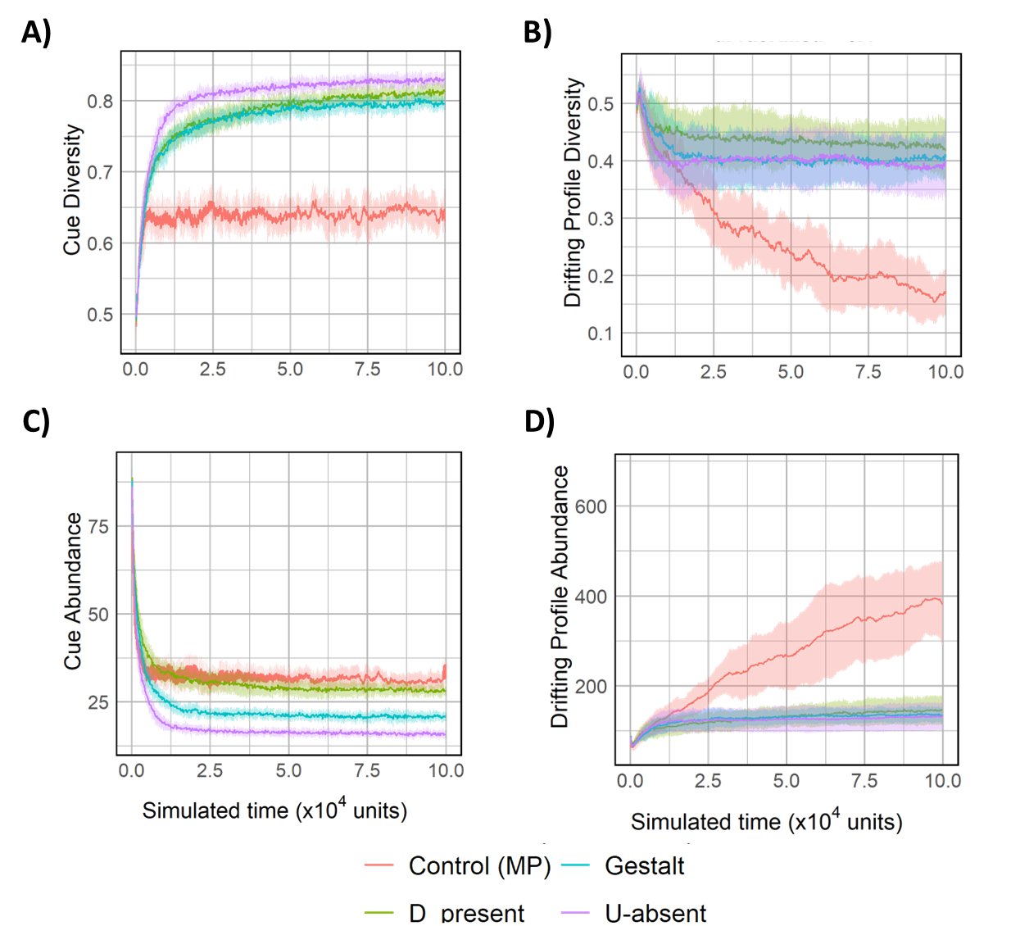  
  
Fig 1: Temporal trajectories for average cue diversity (A), average drifting profile diversity (B), average cue diversity (C) and average drifting profile abundance (D) for various recognition models and control MP. Simulations were run with default parameter values $(μ_{cues}=5; m=40; δ=0.4;t_{gen}=2)$.

## Cue recognition leads to high cue diversity

Cue diversity increased in all recognition models (including control MP) (Fig 1A) compared to drift control (Fig 1B). This result is consistent across all our model explorations, where the cue diversity for drift control declines and has a significantly lower value compared to its recognition model counterparts. U-absent, D-present, and Gestalt models also evolved significantly higher cue diversity compared to control MP (Fig S1A). D-present and U-absent models had significantly higher final diversity compared to the Gestalt model, but no significant difference was observed between the two. Interestingly, while multiple lineages can survive in the population, high cue diversity is also observed in simulations where a single lineage survives (Fig S1B), suggesting high amounts of initial cue diversity are not needed to achieve the high diversity required to sustain a genetic recognition system.

Cue abundance for all recognition models and control MP decreased over time (Fig 1C) compared to drift control (Fig 1D), and this result is also uniform across all subsequent parameter explorations of our model. All four models differed significantly, with the largest decrease in Control MP, followed by D-present, Gestalt, and U-absent models (Fig S1C). Thus provided a cue recognition system exists; high cue diversity can evolve under intraspecific parasitism with metabolic costs to cue production.

U-absent and D-present recognition models show higher success in stealing resources from other colonies compared to Gestalt (Fig S1D).

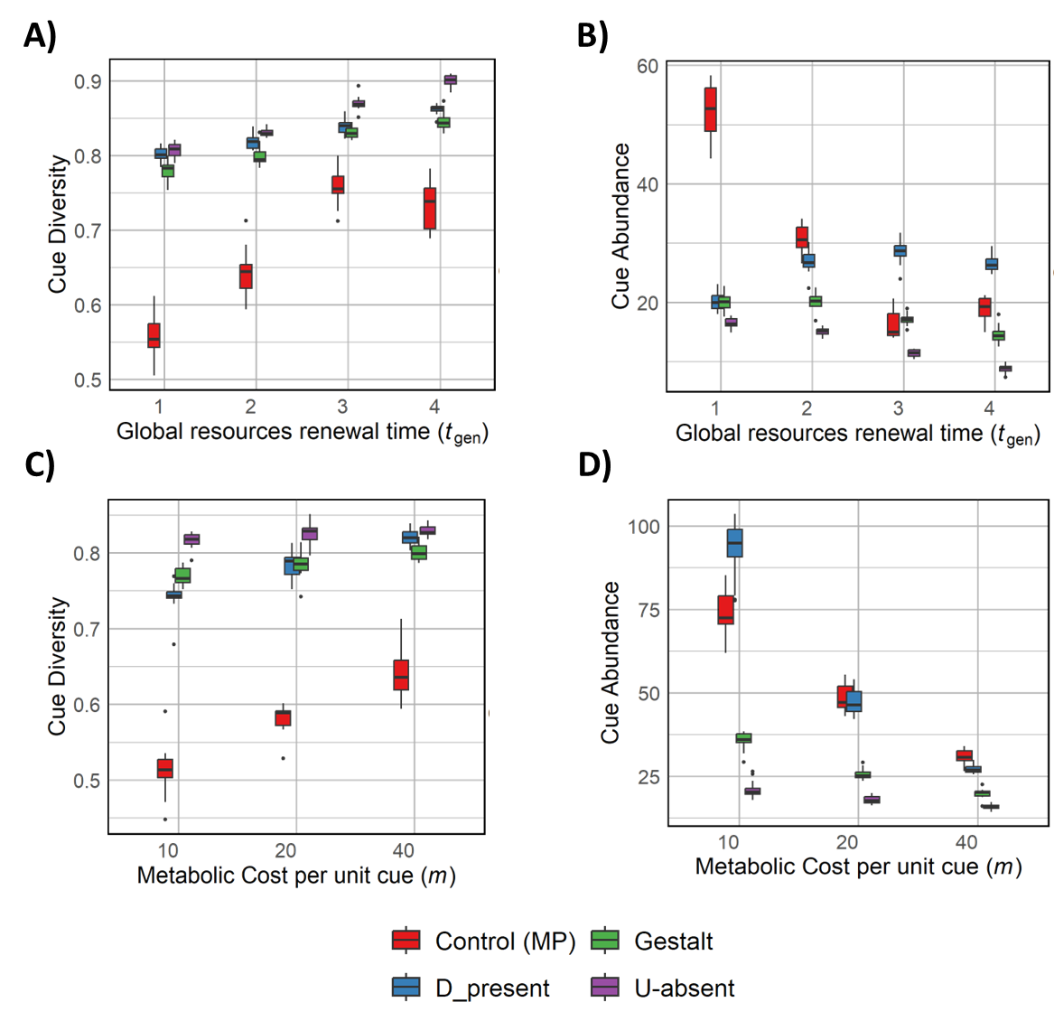  
Fig 2: Box plots for cue diversity (A,C) and cue abundance (B, D) for varying $t_{gen}$ (A, B) and varying metabolic costs (C, D).

## Decreasing food availability causes an increase in cue diversity

Increasing indicates a decreasing availability of food, as colonies must rely on stealing resources for longer once the global pool is depleted. As a consequence, we observe that the cue diversity increases across all recognition models as the time required for regenerating the global pool of resources $(t_{gen})$ increases (Fig 2A). Specific to the model, cue diversity increased the most for U-absent model with increase in $t_{gen}$, followed by Gestalt, followed closely by D-present (SLM1). Irrespective of the availability of food, U-absent and D-present models had higher cue diversity and stealing success compared to Gestalt model (Fig S2A). This suggests asymmetric recognition models where two individuals might not perceive each other identically are better at maintaining diversity and raiding other colonies. Additionally, higher diversity under starvation conditions leads to better colony defense, as reflected in the reduced stealing success.

Decreasing food availability (increasing $t_{gen}$) led to lower cue abundance for U-absent and Gestalt models (Fig 2B, SLM2). Under low food availability, selection favors lower cue values to reduce the metabolic cost of CHC production (Control MP; Fig 2B). Interestingly, the opposite trend was observed in D-present model, where higher cue diversity is seen with increasing $t_{gen}$. Consistent with previous results, U-absent model had the lowest cue abundance of all models across all $t_{gen}$ values. This reflects the nature of the recognition models. Under the U-absent model, lower cue abundances compared to other colony profiles are selected as they are often accepted as nestmates. Contrary to this, in the D-present model, higher cue abundances are selected for as producing more cues could help in being similar to multiple other colonies. It should be noted though that these values are still a magnitude of order smaller than the total abundance of drift control cues (data not attached).

## Increasing metabolic costs lead to higher cue diversity and lower cue abundance

Cue diversity increased for all models with increasing metabolic costs (Fig 2C). The increase is largest for D-present, followed by Gestalt and then U-absent (SLM3). U-absent model consistently shows the highest cue diversity, followed closely by D-present. Increasing metabolic cost is expected to select for lower cue values, which is reflected in cue abundance decreasing for all models with increasing metabolic cost (Fig 2D). This effect is strongest for D-present, followed by Control MP, Gestalt, and U-absent (SLM4). Consistent with previous results, asymmetric recognition models (U-absent and D-present) had higher success in raiding other colonies compared to Gestalt model (Fig S2B) while showcasing higher cue diversity. However, raiding success did not vary considerably with varying metabolic costs.

Since D-present model selects for higher cue values, metabolic costs provide an opposing selection force. This opposing selection explains the sensitivity of D-present model to metabolic costs. Many D-present replicates also lose their recognition systems by evolving all cue values to be zero under extremely high metabolic costs ($m=80$; only 1 replicate retains the recognition system; data not shown). Our model is robust to variations in metabolic costs as cue diversity increases compared to drift control in all conditions. However, very high metabolic costs can lead to population extinction or evolution of all cue values to zero.

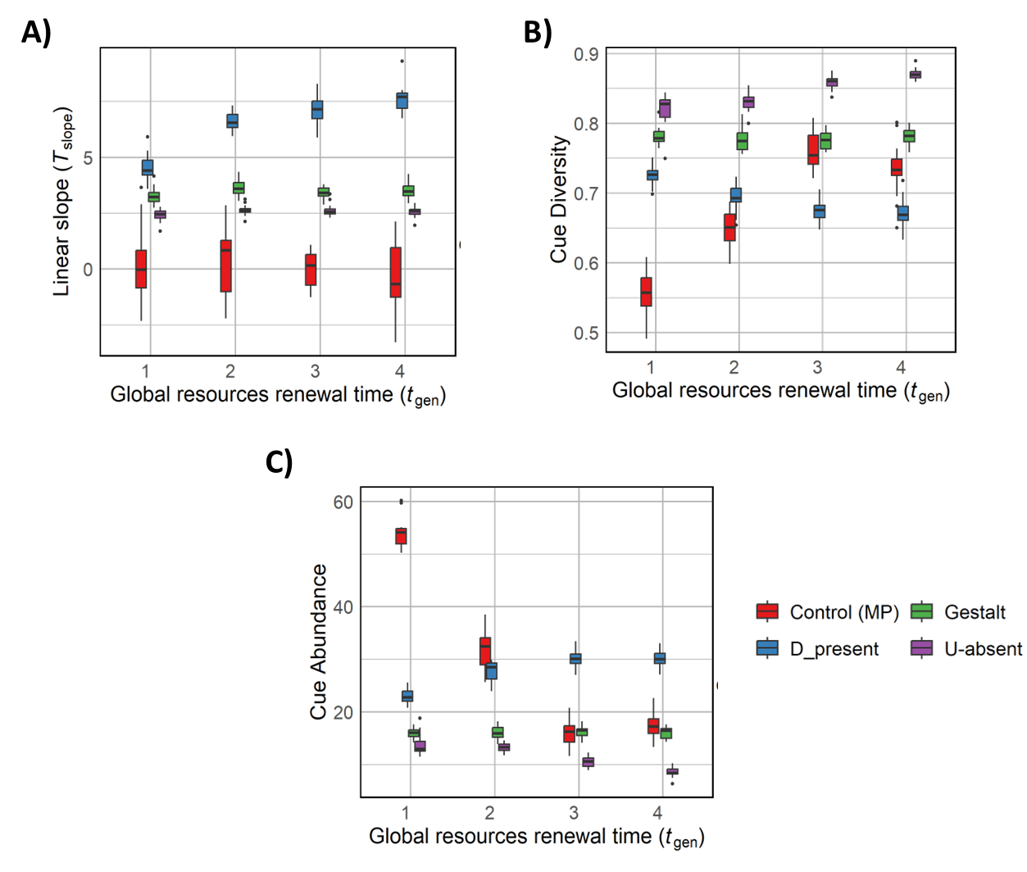  
Fig 3: Box plots for linear slope of tolerance curve (A), cue diversity (B) and cue abundance (C) across varying $t_{gen}$ in the scenario where the tolerance curve and recognition cues are both subject to evolution.

## Stringent recognition systems can co-evolve alongside high cue diversity

Under default parameter conditions, simulations that started with an indiscriminate recognition system (characterized by a flat tolerance curve) capable of evolving, demonstrated the development of a stringent recognition system for the U-absent, D-present, and Gestalt models (characterized by a positive slope $T_{slope}$ in Fig 3A; $t_{gen}=2$). Higher cue diversity and lower cue abundance evolved for all recognition models compared to Control MP (Fig 3B, 3C; $t_{gen}=2$) and drift control (data not shown). This indicates that our model can evolve highly stringent recognition systems while maintaining the high diversity required to support such systems.

As food availability decreased (increasing $t_{gen}$), D-present model evolved a steeper slope for the tolerance curve while the other recognition models are not significantly affected (Fig 3A, SLM5). Interestingly, decreasing food availability resulted in higher cue diversity only for U-absent model, negligible effected on Gestalt model, and lower cue diversity for D-present model (Fig 3B, SLM6). As expected, decreasing food availability leads to lower cue abundance in U-absent model. D-present model showed the opposite trend where cue abundance increased with decreasing food availability (Fig 3C, SLM7).

As anticipated, decreasing food availability resulted in a decrease in raiding success for all recognition models (Fig S2C). U-absent model had the highest raiding success of all models. The results for D-present model are particularly intriguing: despite developing the most stringent tolerance curves, it had comparatively lower cue diversity. By the nature of D-present recognition, higher cue values are selected for as that helps the worker be accepted into multiple colonies. Under low food availability conditions, a more stringent recognition curve would help colonies defend themselves better against intruders expressing higher cue values. Such a system would then push for even higher cue values to increase the raiding success. This feedback could be why a much steeper tolerance curve and lower stealing success is seen in D-present model, even though cue diversity is low and thus colonies are more similar.

It should once again be noted that all systems evolved higher cue diversity and lower cue abundance compared to the drift control.

# Discussion

* Intro to crozier
* Conclusions about diversity
* Conclusions about model system. Refer to supplementary results
* Social parasitism?
* Caveats to the model
* Future exploration

# References

# Supplementary Figures

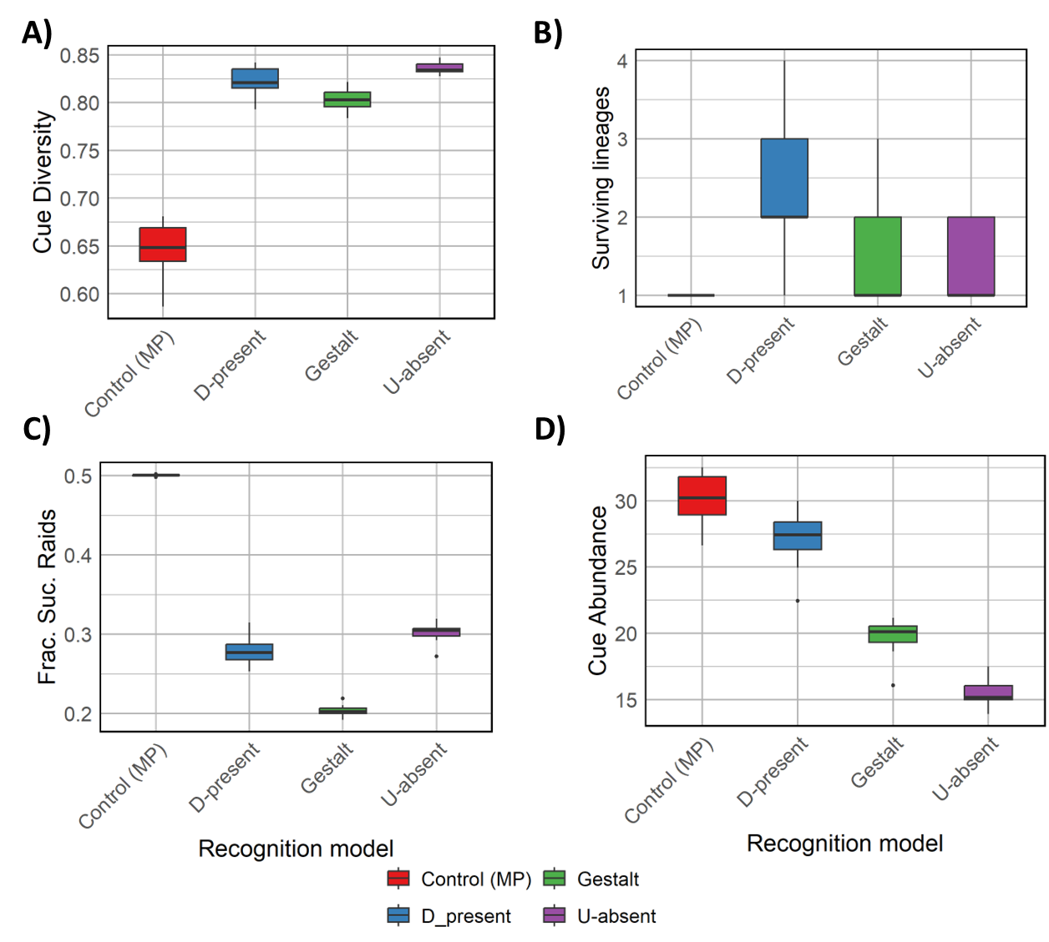  
Fig S1: Boxplots for cue diversity (A), surviving lineages (B), cue abundance (C) and fraction of successful stealing attempts (D) for default parameter values across various recognition models and Control MP.

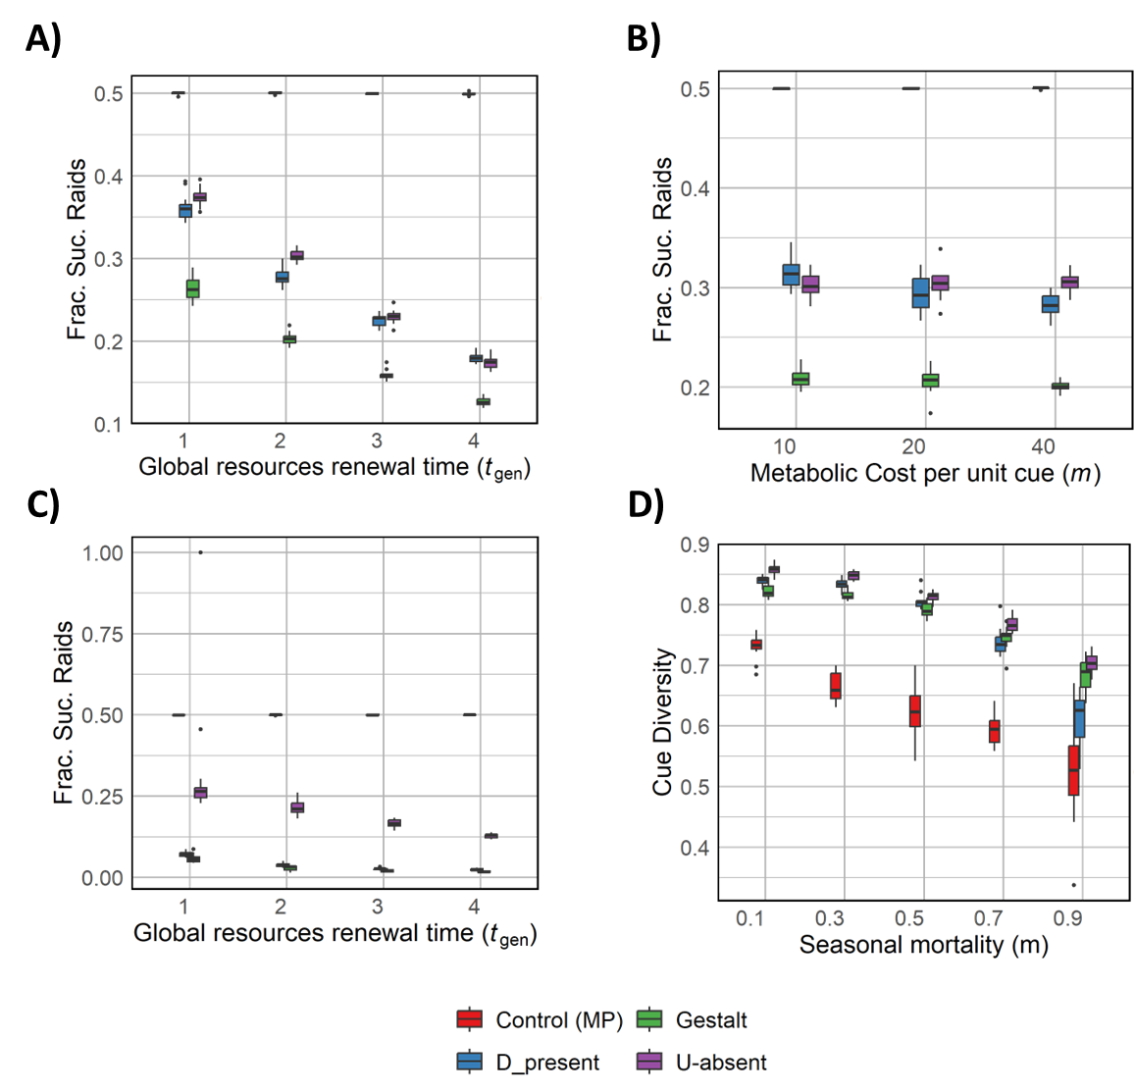  
Fig S2: Box plots for fraction of successful raids over varying $t_{gen}$ (A) and metabolic costs (B) under the non-evolving tolerance curves scenario; Box plot for fraction of successful raids across varying $t_{gen}$ (C) in the scenario where tolerance curves can co-evolve with recognition cues; Box plot for cue diversity across varying seasonal mortality (D) under the non-evolving tolerance curves scenario.

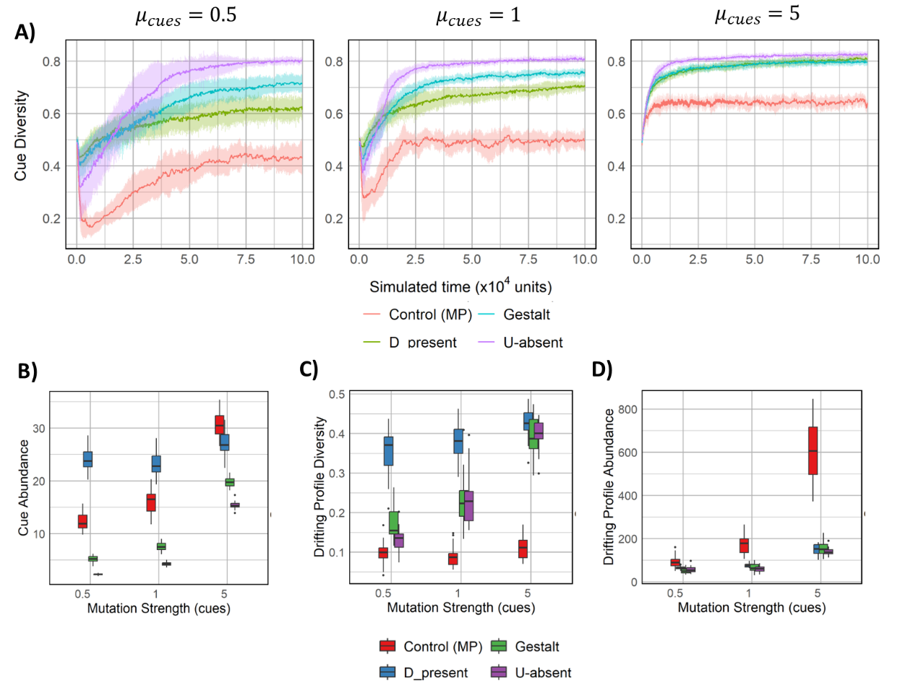  
Fig S3: Temporal trajectories (A) for cue diversity for various values of mutation strength of cues $(μ_{cues})$; Boxplots for cue abundance (B), drifting profile diversity (C) and drifting profile abundance (D) for varying values of $μ_{cues}$. Apart from mutation strength of cues, all parameters have default values.

# Supplementary Results

## Seasonal mortality acts as a bottleneck for diversity

Since seasonal mortality $(m)$ defines the fraction of colonies that die at the end of every season, it can biologically also be understood as the width of bottleneck that the population goes through, albeit based on a proxy fitness measure (food stock of the colony at that instant). This is reflected in the steep decline in cue diversity once more than half the population dies at the end of every season $(m≥0.5)$, (Fig S2D). Since the cue diversity increases for all values of seasonal mortality compared to drift control, our model is robust to variations in this parameter.

## Increasing mutation strength of cues increases cue diversity and abundance

Cue diversity and abundance increased as mutation strength increased (Fig S3A, S3B). This is expected as the cue profile values would explore a larger numeric space due to increased drift under higher mutation strength (Fig S3C, S3D). Interestingly, an initial dip in cue diversity occurs for low mutation strength values. This initial loss in diversity could be due to a bunch of fit lineages that benefit from a low mutation strength and monopolize the population with their offspring. However, a subsequent rise in cue diversity is seen, indicating our model is robust to variations in the mutation strength of cues. This is subject to limits, as higher mutation strength resulted in population extinction for D-present model.

# Supplementary Linear Models

## SLM1: Effect of recognition model and $t_{gen}$ on cue diversity

|  |  |  |  |  |
| --- | --- | --- | --- | --- |
|  | Estimate | Std. Error | t value | p-val |
| (Intercept) | 0.787104 | 0.003365 | 233.922 | 2.35E-219 |
| Gestalt | -0.02627 | 0.004759 | -5.52027 | 1.21E-07 |
| U-absent | -0.01224 | 0.004759 | -2.57213 | 0.010943 |
| t_gen | 0.01726 | 0.001229 | 14.04748 | 1.88E-30 |
| Gestalt:t_gen | 0.005207 | 0.001738 | 2.99682 | 0.003127 |
| U-absent:t_gen | 0.014284 | 0.001738 | 8.220801 | 4.50E-14 |

Residual standard error: 0.02284 on 232 degrees of freedom   
Adjusted R-squared: 0.9307  
F-statistic: 459.7 on 7 and 232 DF  
Reference: D-present

A positive coefficient for the interaction terms indicates an increase in cue diversity for all recognition models with increasing $t_{gen}$. This increase is the highest for U-absent followed by Gestalt and D-present.

## SLM2: Effect of recognition model and $t_{gen}$ on cue abundance

|  |  |  |  |  |
| --- | --- | --- | --- | --- |
|  | Estimate | Std. Error | t value | p-val |
| (Intercept) | 20.19625 | 0.593249 | 34.04346 | 7.58E-79 |
| Gestalt | 1.860453 | 0.838981 | 2.217515 | 0.027883 |
| U-absent | 0.069693 | 0.838981 | 0.083068 | 0.933893 |
| t_gen | 2.193393 | 0.216624 | 10.12535 | 3.09E-19 |
| Gestalt:t_gen | -3.87004 | 0.306353 | -12.6326 | 2.23E-26 |
| U-absent:t_gen | -5.00948 | 0.306353 | -16.352 | 5.21E-37 |

Residual standard error: 1.876 on 174 degrees of freedom  
Adjusted R-squared: 0.9036   
F-statistic: 336.4 on 5 and 174 DF  
Reference: D-present

A positive coefficient for interaction term of D-present with $t_{gen}$ indicates an increase in cue abundance as time of resource renewal increases. A negative coefficient (obtained by summing the reference estimate and relevant interaction estimate) for Gestalt and U-absent indicates decreasing cue abundance with increasing $t_{gen}$. This decreasing effect is stronger for U-absent than Gestalt.

## SLM3: Effect of recognition model and metabolic costs on cue diversity

|  |  |  |  |  |
| --- | --- | --- | --- | --- |
|  | Estimate | Std. Error | t value | p-val |
| (Intercept) | 0.519049 | 0.004413 | 117.6176 | 3.34E-199 |
| D_present | 0.211388 | 0.007182 | 29.43216 | 6.97E-78 |
| Gestalt | 0.253262 | 0.006241 | 40.58053 | 1.42E-103 |
| U-absent | 0.294483 | 0.006241 | 47.18547 | 2.15E-116 |
| metabolic_cost | 0.002469 | 9.57E-05 | 25.79207 | 3.65E-68 |
| D_present:metabolic_cost | -0.00032 | 0.000219 | -1.46122 | 0.145396 |
| Gestalt:metabolic_cost | -0.00176 | 0.000135 | -13.0185 | 4.81E-29 |
| U-absent:metabolic_cost | -0.002 | 0.000135 | -14.7887 | 9.81E-35 |

Residual standard error: 0.02139 on 218 degrees of freedom  
Adjusted R-squared: 0.9522   
F-statistic: 641.9 on 7 and 218 DF  
Reference: Control MP

An increase in cue diversity is observed with an increase in metabolic costs for all recognition models. This effect is the strongest for D-present followed by Gestalt and then U-absent.

## SLM4: Effect of recognition model and metabolic costs on cue abundance

|  |  |  |  |  |
| --- | --- | --- | --- | --- |
|  | Estimate | Std. Error | t value | p-val |
| (Intercept) | 67.92936 | 1.866925 | 36.38569 | 1.44E-94 |
| D_present | 24.61468 | 3.038423 | 8.101135 | 3.85E-14 |
| Gestalt | -34.7958 | 2.640231 | -13.1791 | 1.47E-29 |
| U-absent | -46.8724 | 2.640231 | -17.7532 | 3.22E-44 |
| metabolic_cost | -0.67059 | 0.040499 | -16.5581 | 2.04E-40 |
| D_present:metabolic_cost | -0.8804 | 0.092817 | -9.4853 | 4.35E-18 |
| Gestalt:metabolic_cost | 0.42872 | 0.057275 | 7.485335 | 1.74E-12 |
| U-absent:metabolic_cost | 0.557674 | 0.057275 | 9.736831 | 7.83E-19 |

Residual standard error: 8.419 on 218 degrees of freedom  
Adjusted R-squared: 0.8524   
F-statistic: 186.7 on 7 and 218 DF  
Reference: Control MP

Cue abundance decreases for increasing metabolic costs for all recognition systems. This effect is the strongest for D-present, followed by Gestalt and U-absent respectively.

## SLM5: Effect of recognition model and $t_{gen}$ on evolved tolerance slope

|  |  |  |  |  |
| --- | --- | --- | --- | --- |
|  | Estimate | Std. Error | t value | p-val |
| (Intercept) | 0.247509 | 0.277595 | 0.891618 | 0.373521 |
| D_present | 4.175933 | 0.392579 | 10.63718 | 8.81E-22 |
| Gestalt | 2.687111 | 0.392579 | 6.844766 | 6.77E-11 |
| U-absent | 2.075587 | 0.392579 | 5.287056 | 2.87E-07 |
| t_gen | -0.01079 | 0.101363 | -0.10644 | 0.915327 |
| D_present:t_gen | 0.819278 | 0.14335 | 5.715242 | 3.35E-08 |
| Gestalt:t_gen | 0.203363 | 0.14335 | 1.41865 | 0.157343 |
| U-absent:t_gen | 0.112421 | 0.14335 | 0.784246 | 0.433696 |

Residual standard error: 0.8439 on 232 degrees of freedom  
Adjusted R-squared: 0.888   
F-statistic: 271.7 on 7 and 232 DF  
Reference: Control MP

Increasing $t_{gen}$ causes a significant increase in evolved tolerance slope for D-present model. Other models are not significantly affected by varying $t_{gen}$.

## SLM6: Effect of recognition model and $t_{gen}$ on cue diversity in co-evolution scenario

|  |  |  |  |  |
| --- | --- | --- | --- | --- |
|  | Estimate | Std. Error | t value | p-val |
| (Intercept) | 0.530174 | 0.007936 | 66.80279 | 4.66E-153 |
| D_present | 0.18834 | 0.011224 | 16.78046 | 7.37E-42 |
| Gestalt | 0.246869 | 0.011224 | 21.99521 | 1.39E-58 |
| U-absent | 0.269773 | 0.011354 | 23.76051 | 5.79E-64 |
| t_gen | 0.057501 | 0.002898 | 19.84171 | 8.25E-52 |
| D_present:t_gen | -0.06931 | 0.004098 | -16.9112 | 2.74E-42 |
| Gestalt:t_gen | -0.05653 | 0.004098 | -13.794 | 5.62E-32 |
| U-absent:t_gen | -0.04064 | 0.00413 | -9.83941 | 2.64E-19 |

Residual standard error: 0.02461 on 232 degrees of freedom  
Adjusted R-squared: 0.9081   
F-statistic: 338.2 on 7 and 232 DF  
Reference: Control MP

A decrease in cue diversity is observed with increasing $t_{gen}$ for D-present model. An opposite trend is seen in U-absent. The coefficient for Gestalt is quite close to zero albeit statistically significant.

## SLM7: Effect of recognition model and $t_{gen}$ on cue abundance in co-evolution scenario

|  |  |  |  |  |
| --- | --- | --- | --- | --- |
|  | Estimate | Std. Error | t value | p-val |
| (Intercept) | 60.04046 | 1.165459 | 51.5166 | 5.49E-129 |
| D_present | -38.4705 | 1.648207 | -23.3408 | 8.24E-63 |
| Gestalt | -43.589 | 1.648207 | -26.4463 | 5.71E-72 |
| U-absent | -43.9453 | 1.648207 | -26.6625 | 1.38E-72 |
| t_gen | -12.2031 | 0.425565 | -28.6752 | 3.21E-78 |
| D_present:t_gen | 14.7344 | 0.60184 | 24.48224 | 3.08E-66 |
| Gestalt:t_gen | 12.02292 | 0.60184 | 19.97693 | 2.54E-52 |
| U-absent:t_gen | 10.34779 | 0.60184 | 17.19359 | 2.82E-43 |

Residual standard error: 3.686 on 232 degrees of freedom  
Adjusted R-squared: 0.889   
F-statistic: 274.3 on 7 and 232 DF  
Reference: Control MP

Cue abundance shows an increasing trend for D-present and decreasing trend for U-absent as $t_{gen}$ is increased. Similar to cue diversity (SLM6), coefficient for Gestalt model is quite close to zero, albeit statistically significant.